
IBM Proposal for Gap REDW

Presented to The Gap Inc.
By IBM Business Consulting Services
425 Market Street
San Francisco, CA

Disclosure Statement
The information in this proposal shall not be disclosed outside the The Gap Inc. and shall not be duplicated, used or disclosed in whole or in part for the purpose other than to evaluate the proposal, provided that if a contract is awarded to IBM as a result of or in connection with the submission of this proposal, The Gap Inc. shall have the right to duplicate, use or disclose the information to the extent provided in the contract. This restriction does not limit the right of The Gap Inc. to use information contained in the proposal if it is obtained from another source without restriction. IBM retains ownership of this proposal.
IBM's products and services are proposed under the terms of the IBM Customer Agreement.
This proposal is valid for 30 days from the date of this response unless extended in writing by IBM.
Table of Contents
Executive Summary 2
1 IBM Qualifications 6
1.1 History and Background 6
1.2 Financial Description 7
1.3 Quality Assurance 7
1.4 References 8
1.5 Electronic Data Exchange 10
2 Project Description and Scope (RFI 2-I and 2-II) 11
2.1 Project Description 11
2.2 The Gap Inc. Project Scope Objectives 11
3 IBM Approach 13
3.1 Approach – Overview 13
3.2 Approach - Key Activities 14
3.2.1 Strategy and Planning (Phase I) 15
3.2.2 Solution Outline (Phase I) 16
3.2.3 Macro Design (Phase I, Phase II) 16
3.2.4 Micro Design (Phase II) 17
3.2.5 Build (Phase II) 17
3.2.6 Deploy (Phase III) 18
3.3 Approach Accelerators 18
3.4 Our Approach Supports Development of the “Electronic” Workplace 22
3.5 Our Approach Supports Development of a Roadmap to Data Gov. 23
4 Enterprise Architecture Solution (RFI Pages 7-9) 26
4.1 IBM’s Approach to the Overall Solution: Provides Benefits to Gap 26
4.2 IBM Respone to Gap Architecture Statements 31
5 Project Timeline (RFI Section III) 34
6 Gap Questions (RFI Section IV) 35
7 Deliverables 37
8 IBM Differentiators 40
8.1 Our Experience Implementing EIA Solutions 40
8.2 Commitment to Providing Solutions for the Retail Industry 41
8.3 Leadership in the Delivery of Business Intelligence Solutions 42
8.4 Our Knowledge of Finance 44
8.5 Our Experience Delivering Operating Cycle Time Improvements: 45
9 Pricing, Project Assumptions, and Resource Plan 53
9.1 Project Pricing 53
9.2 Proposed Milestone Based Payment Schedule 54
9.3 Project Assumptions 54
9.4 IBM Resources and Role Descriptions 56
9.5 Project Resource Organizational Diagram 58
9.6 Gap Resource Requirements 59
10 Team Member Resumes 60

Executive Summary
IBM Approach and Differentiators

IBM Qualifications

History and Background

International Business Machines Corporation (IBM) is a widely held, publicly traded company listed on the New York Stock Exchange. IBM was incorporated in the State of New York in 1911. Originally named the Computing Tabulating Recording Company, it became IBM in 1924. Today, IBM has more than 310,000 employees in over 160 countries. In 2004, IBM reported total revenues of $96.2 billion. Headquartered in Armonk, NY, IBM is the world's largest information technology company.
At IBM, our commitment is to lead in the creation, development, and manufacturing of the industry’s most advanced business systems and information technologies. Our portfolio of solutions and services, worldwide infrastructure and world-class service professionals translates these advanced technologies into tangible business value for our customers.
IBM’s divisions are organized into 8 Business Groups and 6 Industry sectors which operate globally.
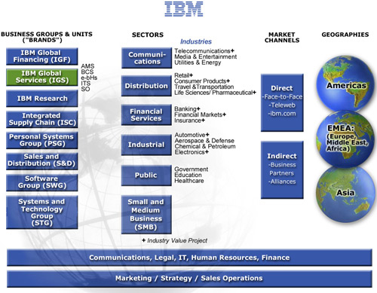
This engagement for The Gap Inc. will be supported by IBM Global Services (IGS), the world’s largest business and technology consulting services provider with annual revenues of over $40 billion. The organizational chart depicting the IBM delivery team’s linkage to IGS senior management is provided in the diagram below.

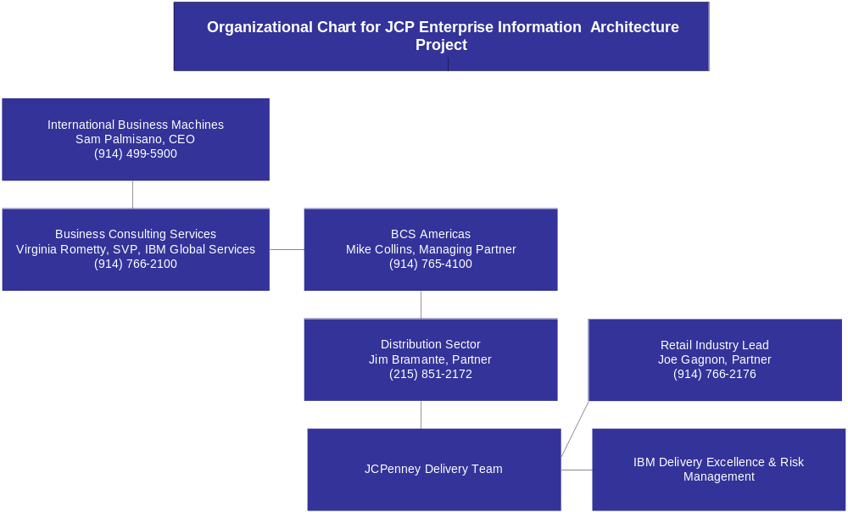

Financial Description
IBM’s total revenue in 2004 was $96 billion with a gross profit of nearly $36 billion. The total assets in 2004 were $110 billion with $79 billion in liabilities. IBM financial statements and the most recent quarterly earnings can be found on our Web site at: http://www.ibm.com/investor/financials/irfiqe.phtml. For further information, IBM’s 2004 annual report is available at http://www.ibm.com/annualreport/.

The most up-to-date credit report can be attained by accessing the Dun and Bradstreet Web site at http://www.dnb.com/dnbhome.htm. IBM's Dunn and Bradstreet number is 00-136-8083.

Additionally, IBM has provided the major rating agencies’ ratings of the Company’s debt securities as of December 31, 2004.

Major Rating Agencies’ Ratings of IBM Debt Securities
Category | Standard and Poor’s | Moody’s Investors Service | Fitch, Inc.
Senior long-term debt | A+ | A1 | AA-
Commercial paper | A-1 | Prime-1 | F-1+

Quality Assurance
IBM has an overriding commitment to the quality of its products, solutions and services provided to clients. IBM is committed to the goals of achieving total client satisfaction as well as delivering superior products, solutions and services by exceeding client requirements.
IBM Global Services follows a rigorous Quality Assurance discipline focused on providing high-quality business solutions in keeping with IBM's overall commitment to quality. IBM’s Quality Assurance discipline, called Delivery Excellence (DE), is integrated into our project management approach. The objective of Delivery Excellence is to recognize, contain and mitigate risks that would jeopardize the success of the project.
Specific steps that will be taken to provide high quality deliverables on this engagement for The Gap include formal deliverable reviews and sign-off procedures, comprehensive unit and integration testing as well as outside Quality Assurance reviews performed regularly by IBM Delivery Excellence SME’s and dedicated risk managers.

References
The following IBM retail clients may be contacted to evaluate our qualifications to support The Gap with this initiative:
 Circuit City Stores, Inc.
Circuit City Stores is a leading electronics retailer in the US, with more than 600 superstores across 45 states. The big box outlets offer a wide array of televisions, DVD players, and audio systems, as well as CDs and DVDs. Circuit City also sells personal computers and peripherals, mobile computing devices, telephones, and video games. In addition to its retail stores, the company sells products through its website. Circuit City also owns Canadian electronics retailer InterTAN.
For Circuit City, IBM is currently working with the IT group to develop and deliver an Enterprise Data Warehouse (EDW). This project is in its fifth phase and is comprised of the EDW and two data marts. In the fifth phase of the project IBM associates will be working with each business area to identify and prioritize their need for data. Currently the EDW has product, inventory and sales data along with associated dimensional data. Phase I was focused on the development of the EDW Strategy and Roadmap which identified the high level vision and strategy for the EDW and associated Tracks of work to realize the vision. Phase II included the design and implementation of the EDW Inventory Proof of Concept which included foundation components such as the Time, Location, and Product subject areas and the baseline component of the Inventory subject area. Phase III included continuing activities in the Supply Chain Track and initiated requirements and analysis activities for the Customer Track. In Phase IV the Inventory subject area was extended to include the In-Stock components. This activity included the implementation of In-Stock data in the EDW, and the creation of an In-Stock data mart for reporting and analysis of Inventory data.
As part of the evaluation process, IBM will provide access to our client:
Mr. Joe McCorey, Vice President Applications Circuit City Stores 9550 Maryland Drive Richmond, VA 23233
Please contact Mr. Joe Gagnon, Partner Business Consulting Services at 914-766-2176 to arrange an interview with Mr. McCorey.
 Children’s Place Retail Stores, Inc
The Children’s Place Retail Stores, Inc. is a leading specialty retailer of children’s merchandise, ages newborn to ten years old. The company designs, contracts, and sells high-quality, value-priced merchandise under the proprietary “The Children’s Place” and licensed “Disney Store” brand names. The company owns and operates over 750 The Children's Place stores, 309 Disney Stores in North America, and its online store, www.childrensplace.com.
For The Children’s Place (TCP), IBM is currently leading efforts to improve visibility into its point-of-sale information, through deployment of an enterprise data warehouse (EDW) based on a retail industry data model. IBM was engaged to implement the IBM Retail Enterprise Data Warehouse model as the foundation for this TCP EDW. In conjunction with TCP, IBM employed its Global BI Method to deploy the REDW solution. The TCP solution is currently in development, with a first release targeted for 2005 year-end deployment. The EDW is being deployed in IBM DB2 on p-Series servers, using the WebSphere Datastage ETL platform. TCP has been able to accelerate the critical data modeling activities and the overall delivery timeline for the first release, as well as establishing the foundation for subsequent releases across the enterprise.
As part of the evaluation process, IBM will provide access to our client:
Mr. Chris Camp, Director of Business Intelligence
The Children’s Place, Inc.
915 Secaucus Road
Secaucus, New Jersey 07094
Please Contact Jim Zalles at 512-633-0241 to arrange an interview with Mr. Camp.
 Kroger Stores, Inc.
Kroger is the nation's #1 pure grocery chain retail company. The company operates more than 3,750 stores coast-to-coast under more than two dozen banners (including about 2,530 supermarkets and multi-department stores). It also runs nearly 800 convenience stores under names such as Quik Stop and Kwik Shop. Kroger's Fred Meyer Stores subsidiary operates more than 125 supercenters, which offer groceries, general merchandise, and jewelry, in the western US.
For Kroger, IBM Business Consulting Services (IBM BCS) designed, developed, and managed the Enterprise Data Warehouse (EDW) data layer for an Operational Data Store (ODS) and Decision Support System (DSS). IBM BCS implemented the 24 TB data warehouse to facilitate category management and ultimately to provide insight for customer care strategies. The data warehouse is already having positive impact by supporting user access to the same quality and depth of information regardless of where they reside in the enterprise. The system enables reporting on 25 product hierarchies and over the next several years will drive Kroger’s specially targeted customer care strategies from a single location.

Kroger Stores Inc.
1014 Vine Street
Cincinnati, OH 45202
Please contact Shirley Waters, IBM Account Executive at 513-762-4480 to arrange an interview with a Kroger executive.

Electronic Data Exchange
Is your company capable of issuing invoices, receiving purchase orders, order cancellations, remittance advice and payment via EDI? If not, are you willing to do so?
Yes, IBM is capable of issuing invoices, receiving purchase orders, order cancellations, remittance and payment via EDI.

Project Description and Scope (RFI 2-I and 2-II)

Project Description
The Gap Inc. is evaluating potential suppliers to provide consulting services in support of the Design of an overall reporting and analytic information architecture framework that integrates on to their Enterprise Informational Architecture. The Plan is to improve the usability and availability of data with core operating applications. The selected vendor will assist with the planning, and design of the overall Enterprise Information Architecture. The vendor will assist in the selection of the appropriate tools, and development of an overall implementation plan.
Specifically, the goals of the project are to:
- Goals

Project Scope Objectives
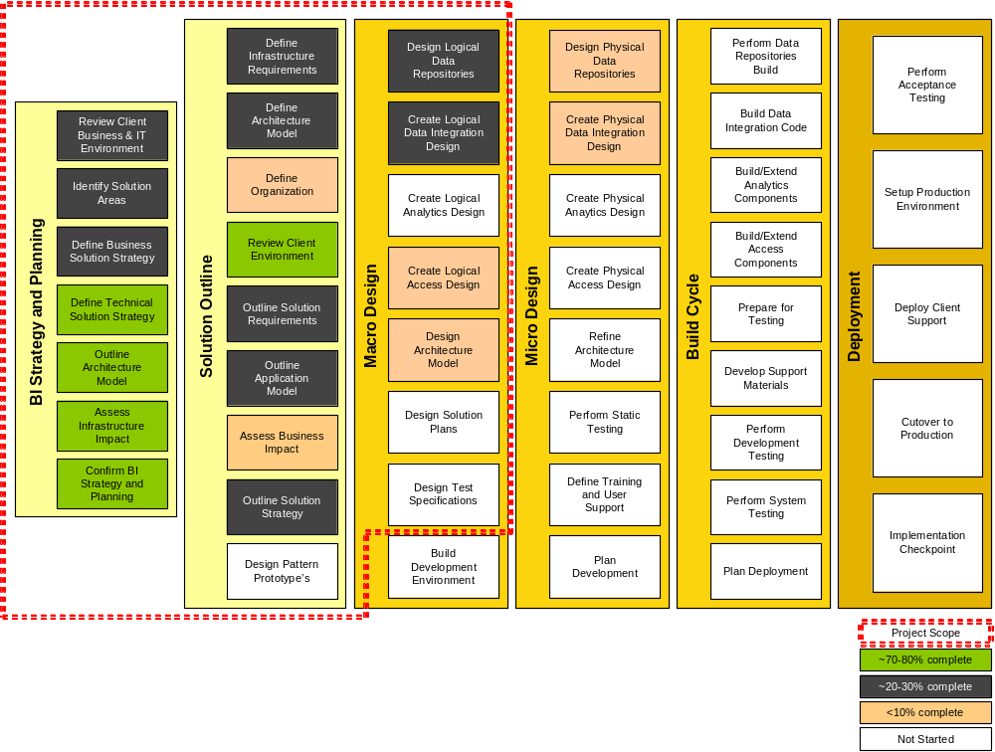

IBM Approach
IBM understands the project description and scope and we have provided an approach that will assist The Gap in achieving the objectives of the project. Our Approach is based on IBM’s BI Methodology that has been used on many customer engagements for the design and deployment of an Enterprise Information Architecture or data warehouse. We have customized our methodology to meet Gap’s requirements and to specifically integrate our approach with efforts already underway at the Gap. IBM recommends putting more focus on value-added activities like validation of requirements and comparison to leading practices instead of generic feature function comparison of tools and “greenfield” requirements gathering approaches.
IBM’s approach to designing and developing BI solutions is multi-phased; each phase building upon those that preceded it. This incremental and iterative approach allows the team to further refine both the design and the release strategy before construction begins and allows IBM to help the Gap assess the viability of the solution in each phase throughout the engagement. The major activities of our standard approach across the entire BI project lifecycle are depicted in the figure below for completeness, with descriptions of each phase, activities and deliverables specific to this engagement following.

Standard Methodology
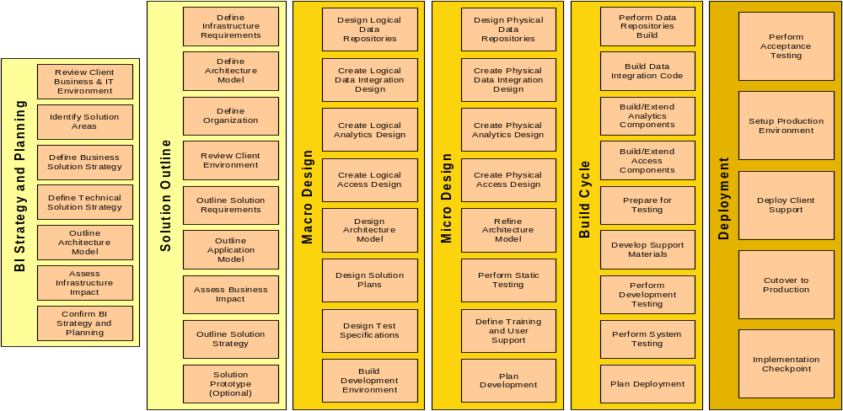

Value of our BI Method
Differentiators | Benefits
- Industry-leading, best-in-class content  - Proven, track record of successful implementations  - Comprehensive: lifecycle, including integrated BI strategy  and planning  - Leverages full IBM methods for systems, infrastructure  - More than just a standalone method: tightly linked with IBM  BI reference architecture  - Open to best of breed technology  - “Tailorable”, flexible, allowing for integration of finance KPI  and process improvement activities  - Globally used in our BI practice  - Integrated with other IBM methods (project management, risk management, etc)  - Linked to and leverages our extensive library of work products and accelerators culled from hundreds of BI projects | - Focuses on both business aspects and technical aspects  of BI  - Increases likelihood of successful BI strategy and  implementation  - Facilitates successful delivery of global, multinational  projects  - Provides better accuracy in project cost estimation  - Thought-provoking content, think outside the box;  challenge your thinking  - Provides a “safety net”; things won’t fall through the  cracks  - Comfort factor; helps sell project internally  - Facilitates knowledge transfer to client staff  - Economical – avoids the need to reinvent the wheel

Strategy and Planning (Phase I)
The purpose of the BI Strategy and Planning activity is to define and validate an integrated Business Intelligence vision for the organization and adopt a common framework around BI needs, solutions and approaches. IBM’s approach expedites this phase by validating Requirements against IBM’s Retail Data Warehouse (REDW) and the Retail Business Solution Templates which have been utilized in other retail engagements.
Activities/Objectives
- Define and validate The Gap’s BI vision, value proposition & priorities for the organization
- Review and confirm current financial reporting issues
- Leverage IBM’s RBIS to adopt a common framework around BI needs, solutions and approaches.
- Assess The Gap’s existing initiatives and impact/dependencies on this environment
- Assess The Gap’s current capabilities (architecture, tools, reporting, etc.)
- Outline future state
- Prioritize initiatives and develop the phased integrated roadmap
- Define the project’s governance approach, guiding principles and procedures
- Develop the high level business case to support the finance rollout and prioritization of other functional areas
- Conduct a leading practices and guiding principles workshop to educate The Gap resources on retail BI leading practices

Solution Outline (Phase I)
The purpose of the Solution Outline activity is to provide a scoping validation in which the solution complexity, architecture, and scope are defined and the overall strategy and approach for the design and implementation effort is developed. Additionally, the business case is articulated with prioritized functionality and subject areas. This allows a more detailed estimate of the phase costs, benefits, schedule and other key information to help you make an informed investment decision regarding a potential new solution before additional resources are expended on more work. Leading practice tool functionality will be leveraged to create system requirements for tool validation/selection. Although our approach does not include an RFI and/or RFP for tool selection, these could easily be developed from the requirements and accelerators.

Activities/Objectives
- Define/validate the components of the solution (business, architecture, organization) including tool validation/selection (OLAP, ETL)
- Create a conceptual, high-level view of the solution (long term and for initial roll-out)
- Scope the selected business solution identified under BI strategy roadmap
- Evaluate financial reporting processes
- Define and validate business requirements and key performance indicators
- Outline solution
- Perform a gap analysis vs. the recommended architecture
- Validate high-level conceptual data model from RBIS
- Identify potential data sources
- Gather usability / user interface requirements
- Assess organizational impact
- Outline solution deployment and transition strategy
- Develop metadata strategy
- Develop data quality and governance strategy
- Define key analytic use cases

Macro Design (Phase I, Phase II)
The purpose of the Macro Design activity is to lay the groundwork in preparing for the Release phases by developing architecture, designed to withstand many business changes through the delivery of the solution releases and beyond. Macro Design moves the focus from business to the solution’s technology strategy, addressing the global, architectural issues that affect the releases. The standards, guidelines and architectural work products developed in the Macro Design phase are designed to help minimize long term development cost by reducing rework, from release to release.

Activities/Objectives
- Top-level, logical design for the BI solution including the data integration system, the data repositories, the analytics system and the access system
- Design architecture model
- Finalize technology selections
- Design solution deployment plans
- Build development environment by leveraging IBM’s Toronto Lab environment
- Initiate iterative prototype development

Micro Design (Phase II)
The purpose of Micro Design is to prepare for the build cycle of a specific release of the solution by driving the architecture and design to a release specific and implementation platform view. Micro Design is the first of three sub-phases repeated for each Release Phase of the solution. Whereas Solution Outline and Macro Design phases take a release independent view, Micro Design focuses on a specific release. Micro Design refines many of the same project outputs addressed in the prior two phases but narrows the scope to the release and goes to a greater level of detail.
The Micro Design activities for this initiative would focus on the initial finance solution to be deployed in Phase 3.

Activities/Objectives
- Develop final set of blueprints for building the solution
- Create physical design for the BI solution including the data integration system, data repositories, analytics system and the access system
- Design new financial reporting processes
- Refine architecture model
- Perform walk-through
- Develop test plans (system, integration)
- Create detailed design specifications for the financial reports and KPI’s

Build (Phase II)
The objective of the Build Cycle sub-phase is the development and testing of the solution Release. This is an iterative process with each Build Cycle containing several incremental programming and testing cycles. An assessment of business conditions and validation of the release strategy is performed before the construction of each release to provide an opportunity to adjust the design and release strategy to help respond to changes in business conditions.

Activities/Objectives
- Construct the BI solution including the data integration system, the data repositories, the analytics system and the access system
- Configure BI solution components
- Build data cleansing routines
- Perform unit testing
- Perform system, integration testing
- Load data structures with test data
- Perform initial performance tuning
- Finalize deployment plans
- Develop user training
- Release system to Beta users

Deploy (Phase III)
The objective of this sub-phase is the managed roll out of the solution Release. The migration of users from other systems and the required data conversions also are managed in this phase. Each release is evaluated and the results fed back into the assessment of the next release. A pilot may be used to verify that each release functions as expected.

Activities/Objectives
- Implement the BI solution in a “production” environment
- Deploy the system to the finance community
- Train user community
- Perform user acceptance testing
- Load historical data
- Configure system management tools (scheduling, monitoring)
- Obtain management approval for production cutover
- Prepare systems implementation report

Approach Accelerators
Most importantly, our approach will utilize our Retail Business Intelligence Solution (RBIS) toolkit to deliver The Gap’s business objectives with lower overall risk and expedited timeframe. IBM’s RBIS includes:
- Retail Business Intelligence Reference Architecture and Association for Retail Technology Standards (ARTS) Compliant Enterprise Data Warehouse Model that has been successfully leveraged by other retailers.
- Retail Optimized Business Intelligence Infrastructure (server, storage and software)
- Retail specific templates for quick start analytics and reporting for Corporate Financial Management, Store Operations, Merchandising, Customer Management, Product Management and Multi-Channel
- Retail Design and Implementation Services to help retailers prioritize their high business impact areas and allow for an easy deployment
The RBIS Retail Enterprise Data Warehouse Model (REDW) provides a well-organized, fast, and easy to access repository of analytics and metrics to support Business Performance Management and provide for “activity based monitoring” for real-time (on-demand) action to address business conditions in workplaces. It actually contains three models:
1. Retail Data Warehouse Model (RDWM)
RDWM, an ARTS compliant data model, will enable The Gap to consolidate the data from throughout the enterprise into one view. It is an enterprise-wide logical entity-relationship data model. It contains over 70 subject areas, over 600 entities and over 4,000 attributes. The objects in the model are fully defined and documented. It includes commonly required summaries and sample analysis schemas. It is a low-level flexible model, generic and one step from a physical model.
2. Retail Business Solution Templates (RBSTs)
The Retail Business Solution templates are a grouping of measures and dimensions that fulfill a particular business requirement. It organizes the data into specific areas for advanced analysis. RBSTs address typical reporting requirements in the areas of Corporate Finance Management, Merchandising Management, Products and Services Management, Store Operations Management and Customer Management. It provides Data Mart Templates for retail organizations, and enables fast accurate requirements gathering.

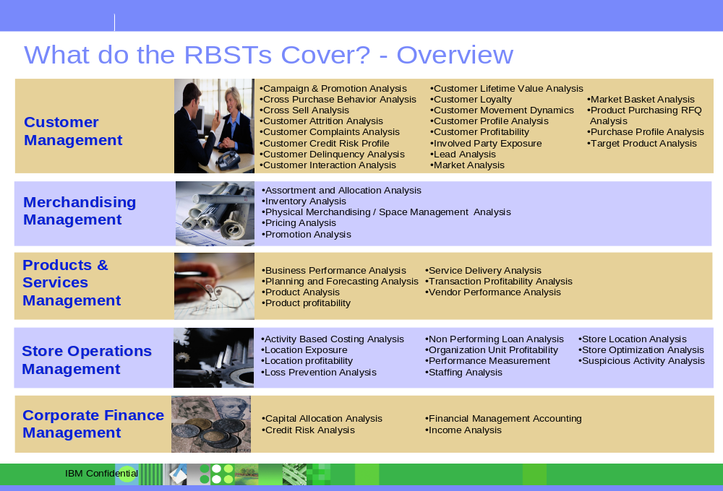
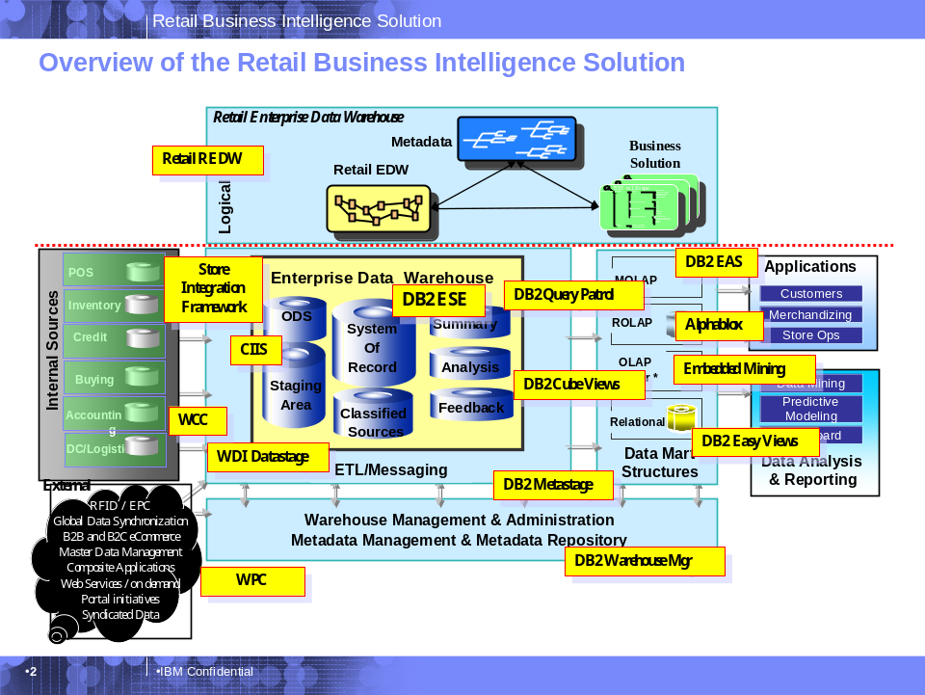

3. Retail Services Data Model (RSDM)
The Retail Services Data Model provides an overall corporate model with common language & terms. RSDM is a Business Classification Model for retailers. It is a classification breakdown of the data required and/or used by the retailer. It contains both model structure and data content.
IBM will leverage the RBIS tools to accelerate the requirements gathering, data mapping and tool validation by enabling:
- A starting point for a consistent view of information across the enterprise with an integrated framework and toolset.
- Quick identification and delivery of advanced analytics and insight into core Retail process areas (see diagram below)
- Rapid, phased deployment
- A packaged, customizable, open environment

To summarize, the approach suggested by IBM, encompassing process, people and technology, offers a more holistic and focused solution to help meet The Gap’s business needs. Additionally, our approach leverages our significant experience and knowledge in Business Intelligence, Financial Reporting and Retail creating an offering with the potential to reduce design and development costs and gain additional business value beginning with the Beta release, thus helping to achieve your cost objectives. This allows The Gap to gain business support, facilitate adoption, and obtain momentum early in the process.

Project Timeline

Deliverables

IBM Differentiators

We believe that IBM is uniquely qualified to support The Gap with the Retail Enterprise Data Warehouse (REDW) initiative. In the following sections we have provided additional information about our experience assisting other leading companies with similar initiatives, our commitment to providing retail industry specific solutions as well as our functional knowledge of finance and reporting processes required for the initial roll-out of the EIA.

Our Experience Implementing EIA Solutions
IBM has successfully completed several data warehousing initiatives for large complex clients similar to The Gap. Below we have provided engagements that included the design, planning and transition to an Enterprise Information Architecture.
United Airlines
United Airlines chose IBM to design and build a powerful Enterprise Data Warehouse (EDW), which encompassed a customer relationship management (CRM) system, to position the airline to improve its customer service and increase operational efficiencies in the changing air transportation industry. The new CRM system – which will eventually manage more than 6 TB of operational and customer information data – uses Business Intelligence (BI) capabilities to identify trends in passenger flight destinations that can enable the airline to more efficiently coordinate and plan flight routes, increase efficiency in managing bookings, and enable one-on-one interactions across multiple CRM channels.
IBM has completed the first phase of the database design and build, including assisting United with extract, transformation (ETL) and load processing. This provides United access to integrated customer and operations data representing more than 1 TB of information leveraged from the reservation centers and United.com for use by thousands of United Airlines employees to better manage United’s customer accounts and improve operations and planning.

Blockbuster
Headquartered in Dallas, Texas, Blockbuster Inc. is a publicly traded subsidiary of Viacom Inc. with more than 8,000 stores throughout the Americas, Europe, Asia and Australia. Blockbuster stores carry a broad selection of movie titles for rent, which range from the hottest new releases to a library of older titles. Blockbuster is also the leading DVD renter, with the majority of the company's stores carrying hundreds of DVD units.
The company wanted to provide a new turnkey customer relationship management (CRM) solution in order to foster customer-centric marketing processes. It chose software applications from SAS and Unica to enable and enhance its direct marketing capabilities with IBM hardware for a reliable, scalable platform to support the CRM solution.
IBM Business Consulting Services (IBM BCS) professionals managed the implementation program and the company's CRM business process improvement to maximize the collection and use of Blockbuster’s customer information. In addition, a group of IBM BCS consultants advised in the technology components of the project, specifically the design and development of the 4.3 TB Operational Data Store (ODS) utilizing Acxiom.


E.I. Dupont
Over a 2 year period IBM has supported Dupont’s efforts to deploy an Enterprise Data Warehouse (EDW) to support the company’s strategic growth initiatives. The project included the initial design and implementation of an EDW architecture that could be leveraged for several phased roll-outs. IBM consultants designed and implemented the EDW architecture and developed the transition plan for Dupont’s two priority areas - Finance and Customer Sales.
The initial finance roll-out deployed a financial KPI dashboard reporting solution to monitor the performance of Dupont’s 25+ strategic business units. The second phase focused on deploying a single customer view of data to provide marketing function executives with customer sales data by product, region and business unit on a global basis. The architecture deployed utilizes a DB2 database, SAP data warehouse and IBM WebSphere portal solution. The effort included integration of over 20 source systems and a data cleansing process to aggregate customer data captured across the multiple source systems. The solution deployed with the help of IBM is currently providing Dupont executives with key insight into business performance.

Commitment to Providing Solutions for the Retail Industry
IBM has a long track record of success in first of a kind innovations and implementations. No company can better assist The Gap in addressing their first of a kind challenges and risks than IBM. A few brief examples of this are:

- First of a kind IBM Research innovations such as advance modeling and analytics for customer segmentation & target marketing, retail promotion analytics and lane optimization

- IBM consistently sets worldwide records for new patents many that are directly related to solutions for the retail industry

- IBM is investing tens of millions of dollars in our Retail Emerging Business Opportunity which is focused on innovating the next generation of retail store business processes, store architecture and store solutions

- IBM, through our Global Retail Alliances is implementing new interoperability patterns using WebSphere tools to define opportunities for delivering retail web services capabilities to serve the needs of our joint strategic retail clients

- IBM’s Gaithersburg testing center regularly pushes the outer limits of performance testing and performance optimization for the world’s largest companies
In addition to these examples, IBM, through our Institute for Business Value, performs primary retail industry research to understand and analyze retail industry trends and directions and apply this knowledge to the development of new retail solutions. All together, IBM’s retail industry insights, retail industry business expertise, retail software and hardware solutions, research work and investments, retail software alliances, investments in new retail solutions and next generation retail architectures puts IBM in a position where we are leaders in defining the future industry agenda and the landscape for retail solutions. IBM leverages this position to provide strategic advice to our retail clients. It also affords the opportunity for us to invest in the joint development of new retail solutions or early implementations of these solutions with our strategic retail clients.

Some specific examples of services provided to the retail industry are as follows:

- Bill payment kiosks - Expedites bill payment for customers by using IBM kiosks that process cash, check, or credit cards

- Data center outsourcing services - Manages a customer’s data center

- E-Business hosting for the retail industry - Run and expand online retail activities rapidly and affordably

- Global expense reporting solutions - Transform and automate enterprise processes, enhance expense controls and maximize data visibility

- IBM On Demand Workplace for Retail - Furnish retail executives and associates with a personalized “dashboard” to increase efficiency of conducting business

Leadership in the Delivery of Business Intelligence Solutions
IBM is recognized as the largest and leading Business Intelligence Solution Integrator. IBM operates on all continents with Business Intelligence consultants in 25+ countries and over 2,300 skilled resources worldwide. IBM BCS Business Intelligence operates as a dedicated, global practice spanning each dimension of our IBM BCS organization.
Our BI services & solutions are centered on supporting the basic building blocks of planning, managing & optimizing the business. Our BI services & solutions are thorough including the vision, roadmap and blueprints for designing a fully integrated business intelligence environment, and approaches for maximizing enabling technologies and managing for success.

An Overview of Our BI Service Offering:
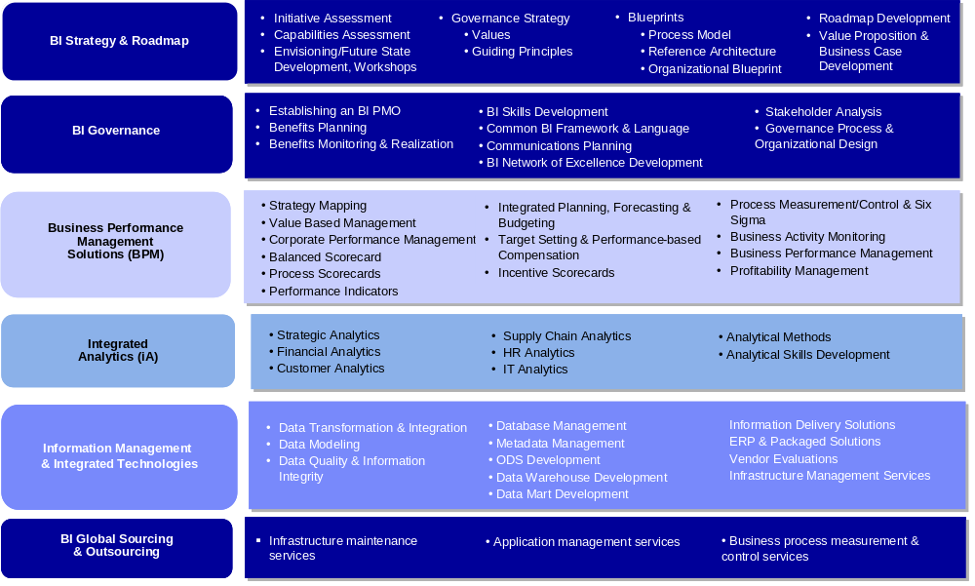

IBM is a worldwide recognized
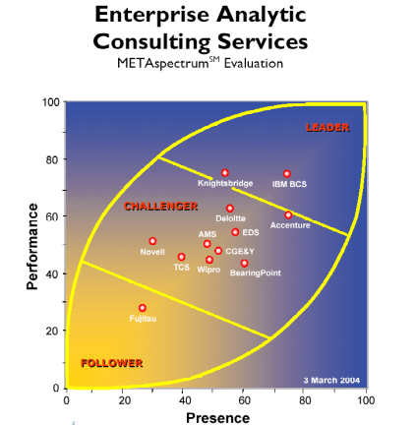
Leader in business intelligence
and data warehousing.

Numerous analyst reports,
Industry awards and product
Reviews attest to IBM’s
leadership in the BI space.

Today, IBM is ranked # 1 in
Business Intelligence and Data
Ware housing and continues to
Show significant growth. IBM’s
Hardware, Software and
Services revenue is now close
To 10 times greater than our
closest competitor.

In the most recently published independent survey conducted by the Meta Group, IBM BCS was recognized as the leader in the Enterprise Analytic Consulting Services METAspectrum.

Source: Survey.com market research report “BI and DW Competitive Analysis Report” at www.survey.com

In addition to this recent Meta Group publication, IBM has been recognized as the leader in the BI space by several other leading IT publications.

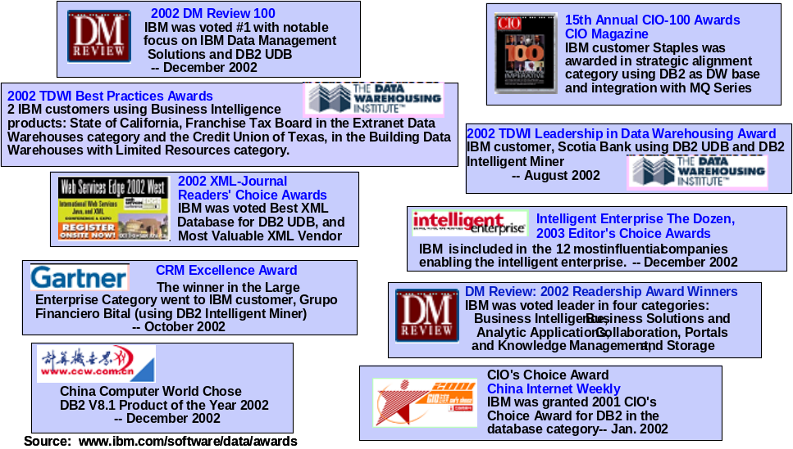

Pricing, Project Assumptions, and Resource Plan

Project Pricing
Below we have provided our pricing estimate for all three phases of the project.
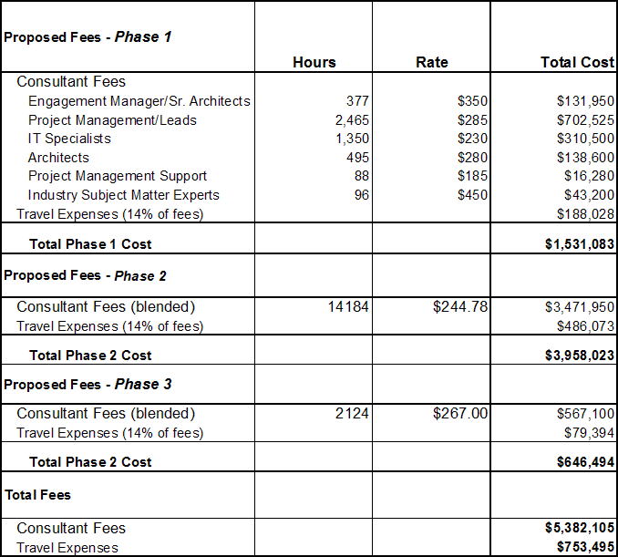
Responder should address the following pricing issues as well: Travel expenses will be capped at a percentage of fees. Responders may propose a cap.
IBM will add a 14% fee for travel applied to professional fees.
This engagement will be either a fixed fee or time and material not to exceed. Indicate a preference for one of these options.
IBM is open to either.
The successful responder will be paid on a milestone basis following acceptance of each milestone by The Gap. Please propose a milestone schedule that is tied to deliverables specific to this project.

Proposed Milestone Based Payment Schedule
As part of our milestone based payment schedule, each monthly invoice will be reduced by 10.0% of the dollar amount attributable to Services as a holdback. This holdback will be payable on completion of the appropriate milestone. This milestone schedule will be based on completion of the following project deliverables:
• Detailed project plan
• Business intelligence strategy and roadmap
• Business case
• Business and IT requirements document
• (EIA) conceptual data model
• Tool and technology selection
• Data quality strategy document
• IT organizational strategy document
• Financial prototype deployment plan
• Weekly status reports

Project Assumptions
Pricing Assumptions:
Project management:
- Phase 2 will overlap with Phase 1 by 1 month
- Common reports only will be implemented. Up to 25 common reports will be implemented by "roll-out" in phase 3. A maximum of 5 reports for beta users will be developed during phase 2
- Of the 25 common reports, 20% complex, 40% medium, 40% simple
- One dashboard with up to 10 KPIs for finance will be available for rollout in phase 3, up to 6 for beta users at end of phase 2, and up to 2-3 KPIs for prototype during phase 2
- Data is for just finance initially
- Up to 10 beta users in phase 2, up to 50 users for the roll-out in phase 3
- The finance data needed to support phase 2 implementation will be up to 1 TB of data in the data warehouse and datamart components.
- Up to 25 interviews will be conducted during strategy and planning. Up to 2 workshops will be conducted during strategy and planning.
- Our pricing estimates are based on the proposed IBM architecture and recommended approach outlined in our response
Infrastructure:
- Includes up to 2 interfaces between analytic Information Services Layer and WebSphere Portal Server using MQSeries
- Assumes messages from analytic tools are XML based using standard protocols and will require no translation or mapping just transport management between Information Services Layer and Access Layer
- Tools perform in a J2EE environment and run on IBM app servers with available standard API's.
- Tools have web services capabilities that can be leveraged, if required
- No new interfaces in Phase 3
- Prototype will be one interface to an analytic tool namely MicroStrategy or AlphaBlox.
- AlphaBlox and MicroStrategy will support the financial reporting needs for in scope common reports
- WebSphere portal server is the portal delivery mechanism
- MQSeries is assumed as the transport mechanism for enterprise integration
Portal:
- Architecture: Standards – Portal will be implemented using the following standards: Java, J2EE, JSR-168, WSRP, Struts, JavaServer Faces, JSPs, HTML, XML, and EJB
- Configuration Management: Repository – Assume that a CVS repository (or similar repository) is available.
- Deployment Environment: Portal/Portlets artifacts deployed to development, acceptance test, and production environments
- Phase two:
  - Assumed that DB2 AlphaBlox FastForward is installed in the same WAS instance as WebSphere Portal Sever.
  - Assumed that there is no custom portlet development.
  - Assumed that portal access to MicroStrategy and IBM DB2 AlphaBlox is through IFrame portlets or links.
Project Assumptions:
- The first subject area to be added to new architecture and framework is Finance
- The Gap personnel will install the SW and HW components required for the solution.
- The Gap will obtain SW licenses for the tools needed to implement this solution (Retail Data Model (RDW), Required RBIS components, Datastage, Qualitystage, Profilestage, Metastage, AlphaBlox, MicroStrategy, WebSphere portal)
- The Gap Application managers will test functionality of products/tools
- There will be up to 6 source systems used to feed the data warehouse for Financial reporting and KPIs for ph 2. (Only the ones needed to support the 25 reports/KPI’s selected)
- There will be up to 10 individual interfaces (ETL processes) for those 6 source systems for ph 2.
- The Gap will be responsible for providing extracts from the source systems to the delivery team based on detail specifications
- Data cleansing in The Gap source systems and data conversion activities will be the responsibility of The Gap resources
- The Strategy and Roadmap components will run a parallel path with the “Requirements/Design common for financial reporting” in ph 1.
- Project Phase 1: Develop Enterprise Information Architecture Transition Plan with software recommendations. No prototype dashboard.
- Project Phase 2: Implement initial Financial Reports to new Dashboard within the new infrastructure (beta users). Portal integration with BI engines via IFrame portlets or links.

IBM Resources and Role Descriptions
Engagement manager: Responsible for the overall delivery of the project and the relationship with the The Gap project sponsor.
Project Manager: Responsible for the delivery of the project and the day-to-day interface with the delivery team and the Gap project manager.
Business Analyst: Business requirements gathering for the finance reporting. Assist process lead with analyses. Interface with the business areas.
Business Process Lead: Review current financial reporting processes and business requirements. Identify process improvement opportunities. Ensure business requirements are integrated into BI solution. Recommend process changes. Assist with roll-out of new processes to finance community. Support the business case development.
SOI/EAI Lead - Enterprise Application Integration lead who will be responsible for design, development, and deployment of the integration architecture model and components. Focus will be on the messaging interface between the information services layer and the electronic workplace and other business user touchpoints.
SOA SME - SOA subject matter expert that will help guide the SOI/EAI Lead during the project on the feasibility, approach, and modeling of services oriented integration. The SME will be responsible for the high level assessment of the services oriented integration model with the overall application integration framework.
Portal Architect: Portal architecture and portal configuration
Portal leadership: Portal Installation / Deployment Specialist, Installation of portal environments (WebSphere Application Server, WebSphere Portal Server, LDAP, HTTP Servers, etc), Basic configuration of portal environments., Development of portal themes and skins for custom 'look' and 'feel'., Deployment of portal development artifacts
BI Data Modeler: Data modeler with specific skills in the field of decision support/BI data modeling constructs. Solid understanding of business context and terms.
BI Strategist: Experienced BI professional with IT architecture skills and business subject matter expertise. Converts business vision or strategy into actionable BI strategy
Infrastructure Architect: IT professional with an appreciation of business content and BI architectural considerations.
Usability Engineer: A human factors or usability engineering professional who applies user centered design (UCD) principles to provide guidance and expertise for developing solutions and producing work product deliverables to confirm that they are usable and productive.

Project Resource Organizational Diagram
Below is the suggested project organizational structure. Engagement team resources named in this proposal will be held for this engagement through January 15, 2006. IBM may have to substitute similar resources if an agreement between IBM and The Gap is not reached by January 15, 2006.
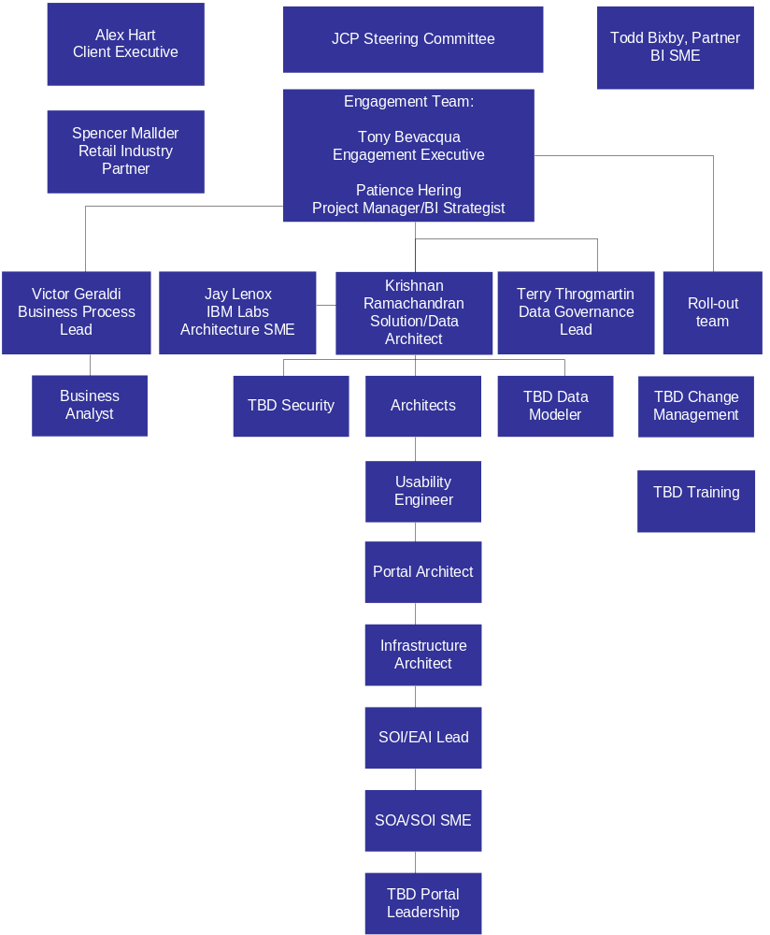

The Gap Resource Requirements
IBM requires the following Gap resources for the duration of the project:
Project Manager (full-time)
Project Sponsor (one day/week)
Business Area SMEs (Finance, HR, Multi-channel, Speed) (1 per functional area 50% of time)
IT Business functional area expertise (Finance, HR, Mutli-channel), (1 per functional area, 50% of time) with one full time lead with knowledge of the data sources for current financial reporting
Technical resources to install software/hardware as needed, (full-time until software/hardware is installed and 25% of time after installation for problem resolution)
DB2 DBA (one day/week to run record counts/reports, etc)
ETL personnel (one day/week to run record counts/reports, etc)
Unix system administrator (full time initially during installs, 50% after installs completed)

Team Member Resumes
Tony Bevacqua
Project role: Engagement Executive
Tony is an Associate Partner in the Financial Management (FM) practice area within IBM Business Consulting Services. The FM practice provides finance strategy, performance management, finance application implementation, finance operations and business risk management services. With over 15 years of combined industry and consulting experience improving finance function performance across multiple industries, Tony has worked with several Fortune 500 finance organizations as both an internal manager and consultant. Experience includes
- Management positions within the financial planning and controller functions for a global pharmaceutical company (prior to consulting)
- Project Manager positions for global finance transformation and business intelligence client service engagements with overall client relationship and project delivery responsibilities
- Leadership positions and practice building responsibilities within the finance transformation practice
Tony has led complex engagements focused on finance process redesign, decision support system implementation and strategic cost analysis. His experience includes managing projects with over 50 resources and several international assignments. Tony’s recent focus includes project management responsibility for global Performance Management and Business Intelligence implementations. He is one of our lead consultants responsible for developing and improving our current business intelligence and performance management services.

Employer History
Feb. 1995 - Present, IBM Business Consulting Services, Managing Consultant
Dec. 1990 – Feb. 1995, Global Pharmaceutical Company, Management positions in Finance and Accounting
Tony held various positions responsible for accounting operations, capital budgeting and financial reporting. Tony implemented a cost control process to support the financial management and assessment of long-term multi-million dollar development projects.
Dec. 1989 – Dec. 1990, Environmental Services Company, Assistant Controller
Tony managed the accounting function for the contracting division and was responsible for general ledger, budgeting, working capital management and reporting. Tony reduced working capital days outstanding for the division from 5 months to 3.5, resulting in over $100,000 in savings annually and a 42% increase in the division’s return on assets.

Assignment History
Project Manager for Global B.I. implementation of Financial and Sales Dashboard Reporting Solution
Project manager position for an engagement tasked to provide dashboard reporting to senior executives of a $25 billion global chemical company. This business intelligence initiative includes the implementation of Business Warehouse and IBM’s WebSphere portal to provide web based reporting of key financial metrics. The overall scope of the project required integration of approximately 25 source systems and data cleansing capabilities to match and aggregate customer master data to enable global customer sales reporting. The project’s initial phase went live in April 04 and the final phase was completed in Sept 05.
Project Manager for Performance Management Process Redesign
Project manager position for the redesign and implementation of new performance management processes for an $8 billion global manufacturer of railway equipment – an initiative intended to provide the initial thrust for a longer term finance transformation effort. Overall responsibility for developing the implementation strategy and managing the rollout of an integrated reporting solution that collected legal and management information from over 60 separate entities worldwide to support global management reporting for over 600 users. Tony led an international team consisting of 60 team members (25 consultants). Project included implementation of a new planning system to support the forecasting process, global consolidation process (legal and management) using SEM-BCS and migration of all reported data to a single data warehouse reporting system. In addition, new forecasting processes were developed and integrated into the client’s overall performance management model. The project was completed in ten months with a successful go live in July 03.
Project Manager for analysis of reporting systems at a global pharmaceutical company
Managed an initiative focused on evaluation of decision support processes and software applications for a $12 billion pharmaceutical company. Recommended decision support process improvements and the common decision support tool. Applications evaluated included Hyperion’s Essbase, Applix’s TM1 and SAP’s SEM solution.
Project Manager for process reengineering initiative
Redesigned financial processes for a multi-billion dollar energy client. This engagement, part of an overall restructuring of the finance organization, included assessment and redesign of the month end financial close process with a focus on identifying and correcting internal control deficiencies. Role included leading the initial process reengineering and developing a phased implementation strategy. Advised the client through the initial phase of the implementation by developing a framework to integrate best practice internal controls, policies and procedures into the redesigned process.

Education and Background

- MBA, Financial Management, Drexel University, Philadelphia, Pennsylvania
- BS, Accounting, Widener University, Chester, Pennsylvania
Todd Bixby
Project role: BI SME
Todd Bixby is a partner in the Business Consulting Services leading Business Intelligence for Retail. He is a seasoned professional with eighteen-plus years of leadership in Business Intelligence and Analytics. He specializes in process improvement and automated solutions that help build and measure customer intimacy, drive sales and marketing effectiveness and provide enhanced business knowledge through the use of advanced integrated knowledge and analytic delivery techniques. He has a comprehensive background in designing and delivering large-scale Information Delivery Environments. Mr. Bixby has specific knowledge in the development of Business Intelligence, analytic, campaign management, decision support, forecasting and data warehousing solutions leveraging leading technologies.

Employer History
September, 2005 – Present, IBM Global Services, Partner
Mr. Bixby is responsible for delivery of retail business intelligence solutions.
November 1995 – June 2005, BearingPoint, Managing Director
Mr. Bixby was responsible for starting the data warehouse and business intelligence practice that included development of the first comprehensive data warehouse methodology. He then led the Consumer segment CRM and Business Intelligence practice. He led specific projects in CPG, manufacturing and retail. He was responsible for defining and managing key alliance relationships for BearingPoint.
May 1993 – November 1995, BSG Consulting, Manager
Mr. Bixby started the data warehousing practice and led the implementation of a real-time sales and inventory portal for a large leisure services company.
March 1991 – May 1993, Information Advantage, Manager
Mr. Bixby led the design, development and implementation of a sales forecasting system for Coca-Cola. Algorithms were then embedded in standard software offering. Developed first sales reporting dashboard and data warehouse for Tupperware, which became the standard software front-end (Briefing Book) for the Information Advantage product suite.
Assignment History
- Delivered an Integrated Marketing Solution including email campaign management solution for large medical device organization.
- Delivered Strategy and Design of a global Business Intelligence Environment including OLAP, Data Warehouse, Data Standards, Business Measures and Data Quality solutions for a large Quick Service Restaurant Chain.
- Delivered a Businesss Intelligence Strategy, Roadmap and Pilot epiphany project for a large Coffee Retailer.
- Managed the delivery of a large scale Financial and Customer information delivery environment for a Fortune 3 automotive/truck manufacturer.
- Managed the delivery of multiple large-scale Internet strategy projects that included customer management approaches as well as possible business spin-offs.
- For large consulting organization, National Alliance Managing Director for e.piphany.
- Managed the delivery of a web enabled integrated data warehouse/ERP solution focusing on costing for a large glass manufacturer.
- Managed the delivery of a web enabled customer information environment, including sales and marketing information, for a large lighting manufacturer.
- Responsible for the delivery of numerous large scale internet-enabled data warehouse projects across multiple industries.
- Responsible for overall data warehouse technical architecture and information delivery process and design for the National Institutes of Health.
- Responsible for the development and implementation of standardized Data Warehousing, Knowledge Management and information delivery Methodology for large consulting organization, The Methodology for an Integrated Knowledge Environment (MIKE).
- Developed and delivered a Rapid Conversion and Implementation project for a major retail rental company that was growing by acquisition and needed an expedited approach to on-board all of their acquisitions in an expedited manner and convert to a single instance of ERP.
- Lead the initiative for BearingPoint to gain a core competency in data warehousing. This included the review and evaluation of data access tools such as query tools, OLAP multidimensional database technology, and web access tools.
- Project manager for a team of developers and analysts responsible for the delivery of an integrated Decision Support System for a major Leisure Services Company. This system included integrating multiple distributed data sources, forecasting, ad hoc and exception reporting.
- Responsible for software vendor evaluation, selection and negotiation as part of a national data warehousing lab environment and alliance strategy.
- Designed databases and directed application design and development for multiple installations of client/server applications including: data warehouses, EIS, DSS and forecasting systems.
- Lead database design effort and played integral role in developing the user interface for an integrated sales information system for a major packaged food company.
- Played an integral role in defining EIS/DSS and Forecasting systems and processes for a major soft drink company.
- Lead designer and project manager for a client/server Demand Forecasting System and Sales Forecasting System developed for major pharmaceutical company.
- Developed multiple client/server forecasting systems for fortune 500 clients in the pharmaceutical, consumer products, retail and leisure services industries. This included defining, developing and applying statistical algorithms and methodologies to create and distribute semi-automated weekly forecast detail.

Education and Background
- MS in Biostatistics from University of Minnesota
- BS in Mathematics from Creighton University

Patience Hering
Project role: Project Manager
Ms. Hering is a managing consultant in the IBM Global Services Business Intelligence Consulting and Services practice with more than twenty years of experience in Customer Intelligence, Customer Relationship Management (CRM), web development, database development and data warehousing. She recently has concentrated on the design and development of large multi-faceted enterprise data warehouse solutions as well as e-business on demand (ebod) and Business Intelligence (BI) offerings. Ms. Hering specializes in innovative uses of web and database technologies to solve executive-level problems. She has managed multi-million dollar engagements in the education, airline, health care, banking, manufacturing, government, chemical, distribution and retail industries in the United States and London.

Ms. Hering is proficient in the use of Oracle, DB2 and the IBM Business Intelligence Method. She has managed e/BI projects in which IBM was the Application Service Provider (ASP). She has experience with 3-tier applications consisting of client workstations, the web and a database server. Ms. Hering has gathered and documented requirements frequently for web and data warehouse projects. She has implemented appropriate data cleansing procedures, designed naming conventions and standards, formulated database administration daily procedures and guidelines and modeled a backup and recovery strategy for the corporations in which she was employed. Ms. Hering has excellent communication and leadership skills, enabling her to lead large IBM/client teams of technical professionals and business users.

Employer History
March 1998 – Present, IBM Global Services - Managing Consultant, Project Executive, Solution Architect, Project Manager, Business Intelligence Strategist
Held multiple roles and been a member of numerous projects since joining IBM in 1998. Recently led the design and implementation of an enterprise data warehouse using SAP BW for one of the largest tobacco companies in the world. The solution enabled the company’s sales force to make better business decisions based on sales volume and product brand.
September 1996 – March 1998, Blockbuster Entertainment, Data Warehouse Manager
Led the implementation of Blockbuster’s first enterprise data warehouse containing customer, product, and point-of-sale information. A national restocking performed using the data in the data warehouse was estimated to have increased corporate revenue by six (6) percent or $378 million.
Other employers include Sara Lee / Champion, Wachovia Bank, USAirways, and GTE Government Systems.

Assignment History
- Project Executive/Business Intelligence Strategist – Led the development of an enterprise data warehouse focusing on sales and products for one of the largest tobacco companies in the world. Responsible for the overall technical design and management of the project team and client relationship. The initial implementation of the project included a Sales-focused application regarding volume data. The Sales application provided business value by creating a central repository for volume information for the business functions (Sales, Marketing, Finance, Operations) to view based on their particular hierarchy. The volume data had integrity and provided a consistent view of the information across the enterprise. SAP BW 3.1C and Oracle was used for the Information Factory running on UNIX. In addition, led the team that evaluated and selected the components and toolset to use in the Information Factory. These components/toolset included but were not limited to: OLAP, data mining, query, reporting, Extract, Transform, Load (ETL), Web portal, security and wireless notification. Started on the project during its initial Business Discovery phase in 2003; completed the delivery of the data warehouse in Jul 2004 and the dashboard GUI front end for Sales in Mar 2005.

- Solution Architect – Responsible for the architecture of an e/BI application for one of the world’s largest airlines. The new application was a thorough rewrite of a legacy system and targeted the airline’s top one percent customers. The front-end consisted of an interactive web application and the back end consisted of an Operational Data Store and a Reporting Data Mart. Oracle was the database management system utilized on a SUN/Solaris hardware platform. The application was targeted to increase revenue by several million dollars.

- Team Lead - Contributed to the business analysis and design of a procurement/strategic sourcing data mart for a $10 billion food distribution company. Participated in JAD sessions with the user community and produced design documents that supported the findings of the team.

- Project Manager - Led the implementation of a two-terabyte operational data store (ODS) for a $6 billion chemical company. The information in the ODS was to be used to populate data marts and to provide a location for adhoc and canned reporting. The ODS was produced from a SAP source system and (once in place) enabled users to no longer interfere with the operational production system when executing reports.

- Data Warehouse Manager – Blockbuster Entertainment. Led the implementation of a 4.2-terabyte data warehouse to provide information on over 3,700 stores for the marketing and product planning departments. Managed a development team for Blockbuster of up to 30 persons including Blockbuster and non-Blockbuster personnel. The team consisted of technical and business persons including Vice Presidents. Implemented a Data warehouse housing several million-row tables and utilizing a massively parallel machine (IBM SP) and Oracle Parallel Server v7.3. Information from the data warehouse enabled "smarter" buying, which resulted in higher revenue per store and enabled the retailer to design direct marketing programs based on customer demographics.

Education and Background

- MBA, Northeastern University
- BS in Computer Science from Baylor University
- Certified Consultant

Victor Geraldi
Project role: Business Process Lead
Victor T. Geraldi is a Senior Consultant in the Financial Management Solutions Practice Area within BCS.
Victor has over fourteen years of Management Consulting experience working with executive level managers in the development and implementation of operational and strategic change initiatives. Majority of client work has been in large-scale, ERP driven, enterprise wide change initiatives. Primary focus has been implementing process improvement, organizational change and shared services initiatives within Fortune 500 Companies. Strong analytical, organizational and project management skills. Familiarity with numerous systems packages and strong PC skills.
Employer History
September 1996 – Present, PWCC/IBM, Principal/Senior Consultant
July 1989 – May 1994, Major Consulting Organization, Consultant
Assignment History
- For a global Electronics Company was the Project Manager for a Shared Services Strategy, Design and Implementation project. Responsible for all aspects of project development including business case, organization design, site selection, migration planning and implementation. Functional areas in scope include order-entry, credit, deductions, cash, inventory and general accounting.

- For a global pharmaceutical company was the Change Management lead for a global ERP implementation. Responsibilities included defining and executing the overall change strategy to be utilized on the implementation. Responsible for developing and managing the work effort across the following change management work streams: Communications, Stakeholder Management, Organizational Readiness, and Human Resources. Scope of the project covered the following functional areas: Finance, Order-to-Cash and Manufacturing.

- For a fortune 500 technology company was the Process Change Manager for an enterprise wide SAP implementation. Responsibilities included managing all organizational and process change activities resulting from the implementation. Managed the development and execution of process change plans across all major finance process areas including G/L, A/P, Assets, Tax, Reporting, Costing. Change plan execution activities included organization and job design, training curriculum development, security profile development, and overall stakeholder management and communication activities. Also managed the development and execution of go-live preparation activities and post-production support for the finance function. Successfully transitioned the client through all phases of the ERP life-cycle.

- For a fortune 500 chemical company was the Business Transformation Manager for the planning and design phase of a global ERP implementation. Responsibilities included preparation and facilitation of process design workshops, development of key performance indicators and directional measures, and the identification of benefit and opportunity areas.

- For a global consumer packaged goods company managed the process and organizational change activities for the corporate finance function for an enterprise wide SAP implementation. Responsibilities included developing and executing; communication and stakeholder management plans for the finance function, finance function process envisioning, organizational impact assessment, organizational design and implementation, job design and implementation, transition planning strategy and site level change readiness activities. Worked with SAP technical personnel in the development of security profiles and acted as work stream liaison for end-user training development and implementation. Successfully transitioned the client through all phases of the ERP life-cycle.

- For a fortune fifty insurance company managed the development of a corporate wide compliance infrastructure. The entire project consisted of over two hundred sub projects aimed at bringing this global insurer into legal and ethical compliance across the company's broad business spectrum. Worked with five senior sub-project managers in scoping their respective projects. Coached these managers in project plan development and management, team building and leadership skills. Enabled managers to obtain project plan approval on time and within budget.

- For a United States Federal Government agency, managed two client teams in an assessment and evaluation of the Financial Management and IT support functions. Developed detailed project workplan for each team defining project content, organization and flow. Assigned project responsibilities to team members and provided technical assistance, benchmarking and performance measurement data required to ensure successful completion of individual project tasks. Motivated staff to achieve project objectives, promoted teamwork. Tracked client sponsor expectations and refined work-plan to satisfy requirements. Tracked work-plan against progress and took actions to resolve any issues. Successfully managed the preparation and submission of team deliverables.

- For a $1.5 billion global services firm, assessed the effectiveness of the finance organization and associated processes on an international basis. Reviewed the relationship between corporate and field offices in 10 different countries and assisted in envisioning a strategy for improving the effectiveness of the global finance function. Activities included interviewing senior and mid level client personnel, facilitating envisioning workshops, and preparing final deliverables.

Education and Background
MBA, in Finance/Information Systems from New York University, Leonard N. Stern School of Business, New York, NY
BS, Finance, Fairfield University, Fairfield, CT

Krishnan Ramachandran
Project role: Solution Architect
Krishnan Ramachandran is an IBM certified Senior IT Architect in the Enterprise Architecture and Technology service area within Application Innovation Services. The objectives of the practice include providing thought leadership, delivery excellence in building enterprise architectures and complex e-business solutions and providing technical leadership in emerging technology areas, such as Grid Computing and e-business On Demand. Mr. Ramachandran has over 17 years of experience in the IT industry providing technical leadership in developing complex e-business architectures and end-to-end enterprise architectures. His specialties include distributed computing, Service Oriented Architecture (SOA), Web Services and grid computing in a variety of industries including financial services and retail. Krishnan is currently a core member of the SOA COE, whose mission is to help clients realize business value from the implementation of Service Oriented Architectures & Web Services in support of IBM’s on demand operating environment. Prior to this he was the lead architect for the Americas grid services team in IBM Global Services, where he provided technical leadership in driving sales as well as architecting solutions leveraging grid technologies.

Employer History

August 2000 – Present, IBM, Senior IT Architect
May 1999 - July 2000, Technology Consulting Company, Architect
May 1995 – April 1999, Financial Services Company, Architect, Lead Technical Specialist
May 1990 – April 1995, Large Technology Consulting Company, Technical Lead
June 1986 – April 1990, Software Consulting Company, Technical Specialist

Assignment History

Senior Architect, Large Consumer Packaged goods company
- Led a team of architects in implementing a marketing led strategy to enhance the brand awareness amongst the youth population. This involved build the next generation architecture based on SOA principles to integrate the services from various service providers.
- Leveraged IBM’s Service Oriented Modeling & Architecture (SOMA) approach to build the Service Oriented Integration architecture.

Senior Architect, Large Technology vendor
- Co-authored a technique paper for a technical transformational approach in architecting a Service Oriented Architecture solution. This approach uses the input from a business transformational analysis engagement to build the high level design for a Service Oriented Architecture implementation.
- Leadership in evangelizing the prescriptive approach to a broader team of architects as well as guidance to technical sales team.

Senior Architect, Large automotive manufacturing company
- Led a grid strategy engagement for a large automotive manufacturing company to build a high level conceptual architecture in implementing grid technologies for their Computer Aided Engineering space. This will enable the customer to integrate the disparate compute resources using a policy based approach and open grid standards. Worked closely with their on demand project execs in positioning grid within the customer’s overall on demand strategy.

Senior Architect, Large Financial Services Company
- Part of an architecture team in implementing an existing wealth management application on a grid. This FOAK solution using IBM research and software group technologies would enable them to respond to their customers at a faster pace. The solution is built using web services standards and Server Allocation for WebSphere Application Server (SAWAS).
- Leading the project executive team in defining a grid strategy engagement as part of the overall on demand alliance.

Senior Architect, Global Credit Card services company
- Led a team of 5-7 persons in designing and implementing an interim release of a web based dispute management application.
- Led a 4 person team in analyzing and designing the common services functionality for the dispute management application, to abstract the common set of functions to be reused across the application.
- This J2EE application was architected based on a pattern-driven reference application architecture and was implemented using IBM WebSphere Application Server, DB2 and MQSeries on an AIX platform. Tools used included Visual Age for Java, WebSphere Studio Application Developer, Rational RequisitePro, Rational Rose, Rational ClearCase, Rational ClearQuest, and Mercury LoadRunner.

Senior Architect, Large CRM application Software Company
- Developed the architecture for a Customer Master solution to help them better understand and serve their customers. Developed a dashboard strategy to help their executives understand the key services issues. The Customer Master solution involved extracting Customer attributes from various silo applications and integrating them in to a data store, which was used to produce reports that would enable the software vendor answer key questions about their customer. The solution entailed using KANA’s CRM application software and reporting products.

Senior Architect, Large Technology vendor
- Part of an architecture team that conducted a detail Performance, Scalability and Availability study for the B2B gateway system of a large Technology vendor. The scope of the study included understanding the technical architecture and business challenges. Based on the gathered technical information and the knowledge of the best practices, a detailed report with recommendations to improve performance, scalability and availability was produced. This report included the technical transaction maps and capacity recommendations to meet the business objectives for the various timeframes. The B2B gateway implementation used WebSphere Business Integrator components, WebSphere Commerce Suite, WebSphere Application Server and MQSeries products.

Education and Background
IBM Certified IT Architect
Post Graduate diploma, Computer Science, Datapro Institute of Technology, India
B.S. in Physical Science, University of Mumbai, India.

Terry C. Throgmartin
Project role: Data Governance Lead
Mr. Throgmartin is a business-oriented senior consultant with over 25 years experience in information systems specializing in Data Warehouse Strategies and Implementations, Data Warehouse Migrations and Upgrades, Information Architectures and Strategies, and Business Discoveries for several industries – Major Retail, Insurance, Transportation, and Financial Services. He is an innovative problem-solver and planner. He has managed and performed technical lead responsibilities on Data Warehouse project teams for implementations from $300,000 to $20 Million.

Employer History
Business Consultant, IBM
Data Processing Officer, Major St. Louis Bank
Software Steering Committee, National User Group
Assignment History
Mr. Throgmartin performed a Technical Architecture role for a major consumer products distribution company implementing an Atomic Enterprise Data Warehouse globally utilizing Oracle 10g RAC with over 10 Terabytes of storage on multiple nodes. The effort included the architecture development and review of the high-level detail design of the ETL processes utilizing Informatica.

Mr. Throgmartin performed an Enterprise Data Warehouse Assessment for a major consumer products distribution company utilizing DB2 UDB running on AIX. The assignment required an analysis of a EDW project implementation in progress to determine the steps necessary to be successful in implementing the EDW in a timely manner and meet performance expectations and business requirements of the Business Users.

Mr. Throgmartin performed a Technical Architect / Teradata DBA role for a major financial credit card company to convert existing Oracle Analytical Applications to a new Enterprise Data Warehouse. The effort involved collecting business application requirements, developing a high level approach, and developing detail project plans for the conversion effort. In addition, he performed DBA functions to set up the Oracle Database Tables on Teradata for the conversion.

Mr. Throgmartin performed Solution Architect and Capacity Planning role for a major retail company to implement an Operational Data Store (ODS) and Epiphany Campaign Management and Analysis system utilizing database utilities and DataStage for Extract, Transformation, and Load of the data to the ODS and Epiphany. The customer had an MVS mainframe with several AIX systems which were utilized for the ODS and Epiphany for the solution architecture.

Mr. Throgmartin architected a CRM Solution for a major automotive company and led the data conversion team on the project utilized a Siebel 7.5 solution. The solution included a Siebel 7.5 Analytics Data Warehouse. The customer had an MVS mainframe with several UNIX systems for client server applications that had to be integrated into the total solution.

Mr. Throgmartin led the Data Quality effort for a major grocery retailer during their Oracle Financials Data Conversion from MVS. The data quality effort required data cleansing of customer name and address information in the U.S. and Canada, as well as customer account de-duplication for accounts payables and receivables. In addition, he developed the Data Migration Plan and assisted in the development of the detail test plans with the customer.

Mr. Throgmartin performed the Data Analysis and Solution Architecture tasks for a major credit card company. He reviewed the existing MVS mainframe applications and defined the necessary conversion efforts for the project.

Mr. Throgmartin developed the Infrastructure Architecture for several major distribution companies. These companies desired to review the primary CRM Solution Vendors and how each vendor could provide the solution to fit in their environment. In addition, he developed the Data Warehouse Strategy for each company’s environment.

Mr. Throgmartin developed the Infrastructure Architecture for three major insurance companies. He developed a comparison of the primary CRM Solution Vendors for each insurance company’s environment and defined how the current SAP solutions would co-exists with a combined data warehouse strategy.

Mr. Throgmartin was the Data Warehouse Architect and Data Conversion Lead for several major data warehouse conversions with single databases from 80GB to 2 Terabytes in size in Major Retail, Transportation, and Insurance Companies. These conversions included moving data from the MVS mainframe, UNIX client server systems, and external sources during the initial conversion as well as on a daily basis. One of these corporate data warehouses which was 2 Terabytes in size in a single database won the DB Expo “Realware” award. In addition, he worked with one of these clients for the following five major upgrades to their data warehouse. In addition, he worked on teams to develop data marts and multi-dimensional analytical databases to provide key performance indicators for the company. Some conversions included Oracle to Teradata and Teradata to DB2 UDB. Other conversions were for upgrading the existing database to a larger and faster platform

Education and Background
BSC Information Management Webster University (GPA 3.95 in process) Associate Degree State Technical Institute of Memphis (GPA 3.95 in 1 yr) Guest Speaker, National Data Warehouse User Convention

